7 RED VALENTINES DINNER OUTFIT IDEAS: CLASSY & ELEVATED

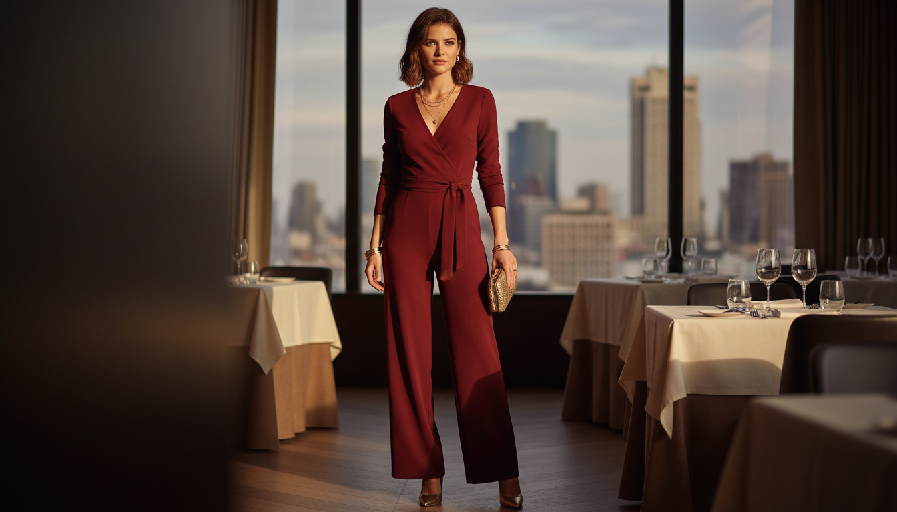

Valentine's Day is right around the corner and finding the perfect look is a top priority. You want something that screams romance but still feels super high fashion. Red is the boldest color you can wear to make a statement. These 7 Red Valentines Dinner Outfit Ideas: Classy & Elevated are exactly what you need to feel confident and beautiful. We are focusing on pieces that look expensive and sophisticated. You can choose deep cherry tones or bright fire engine red to match your personal style. Every single look here is curated to help you stand out during your special evening. It is time to ditch the boring clothes and embrace the color of love. Grab your favorite heels and get ready to turn heads. Save your favorites to your mood board.

# Red Silk Slip Dress

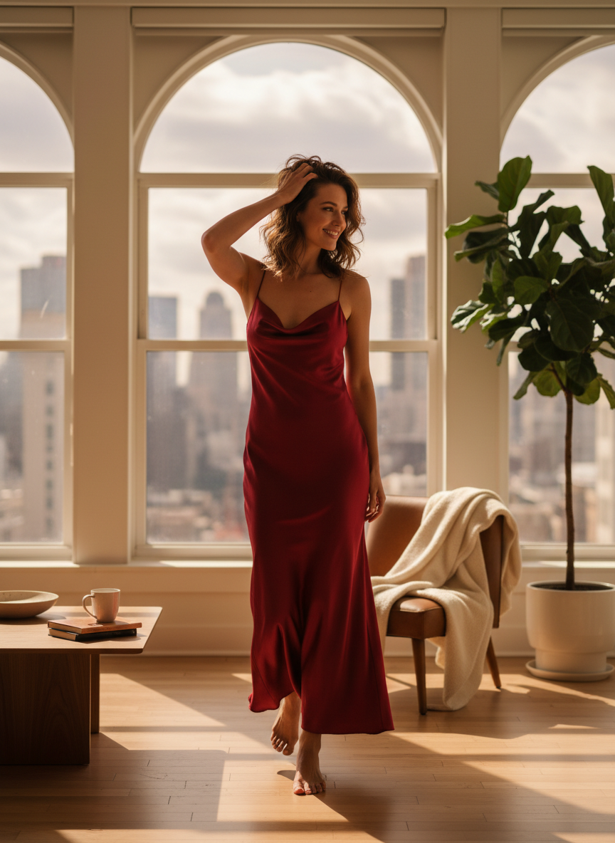

A silk slip dress is a total classic for a romantic night out. The fabric catches the light perfectly and feels amazing on your skin. You can pair this red valentines dinner outfit idea with some gold jewelry and strappy sandals. It is simple but looks like you put in so much effort.

# Red Velvet Blazer



Velvet always feels so luxurious and cozy for a winter date night. This red valentines dinner outfit idea works perfectly over a black bodysuit or even a lace camisole. It adds a textured layer that feels very high end. You should keep your hair sleek to let the blazer be the star of the show. Dark wash jeans or tailored pants complete the look effortlessly.

# Red Leather Mini Skirt



Leather is a great way to add some edge to a classy dinner look. A red leather mini skirt looks incredible with a white turtleneck or a fluffy cream sweater. This red valentines dinner outfit idea balances a bit of sass with a lot of style. Add some sheer tights and knee high boots for the perfect cold weather vibe.

# Red Satin Midi Skirt

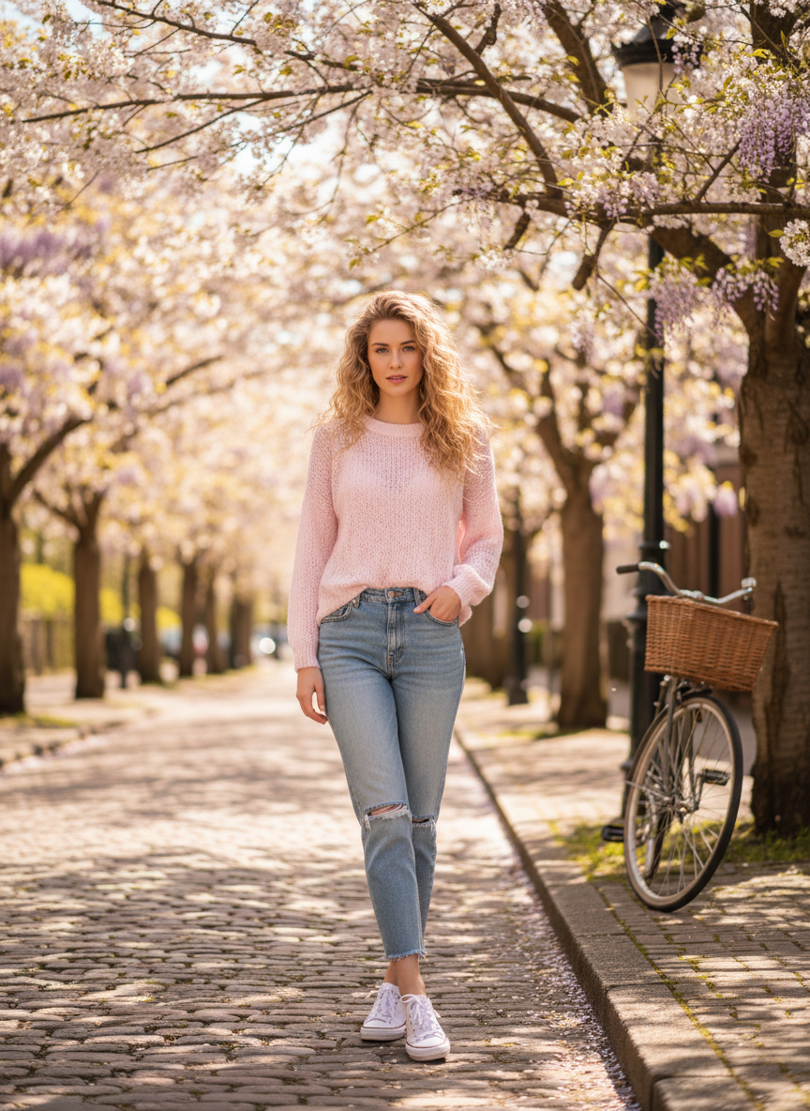

Satin skirts are a staple because they drape so beautifully. This red valentines dinner outfit idea is perfect for someone who wants to look elegant without being too extra. You can wear it with a cropped cardigan or a crisp white button down. The shine of the satin makes the red color look deep and rich.

# Red Off The Shoulder Top

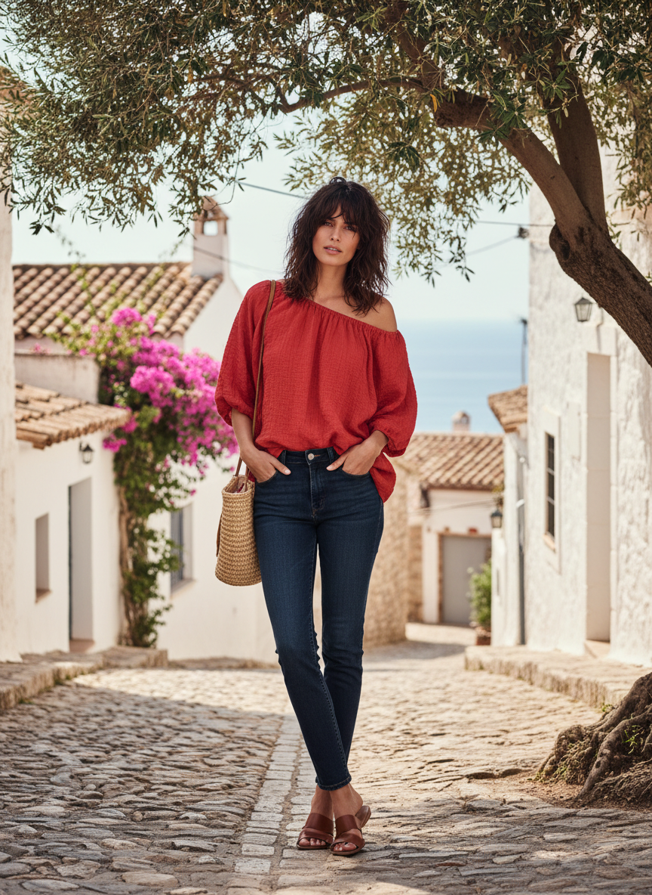

Showing a little bit of shoulder is so feminine and sweet. A red off the shoulder top paired with wide leg trousers creates a very balanced silhouette. This red valentines dinner outfit idea is great for a more relaxed but still elevated dinner. Wear some statement earrings to draw attention to your neckline.

# Red Knit Bodycon Dress

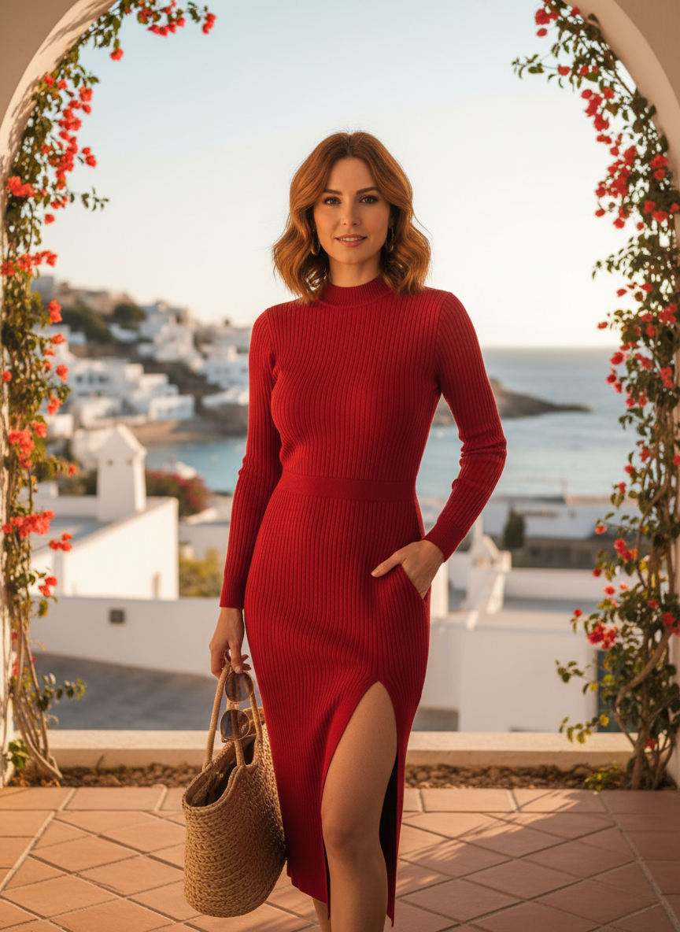

If you want to show off your curves, a knit bodycon is the way to go. This red valentines dinner outfit idea is comfortable enough for a long meal but still looks very polished. The thick fabric keeps everything smooth and feels very high quality. Pair it with a long coat and some pointed toe heels to finish the ensemble.

# Red Wide Leg Trousers

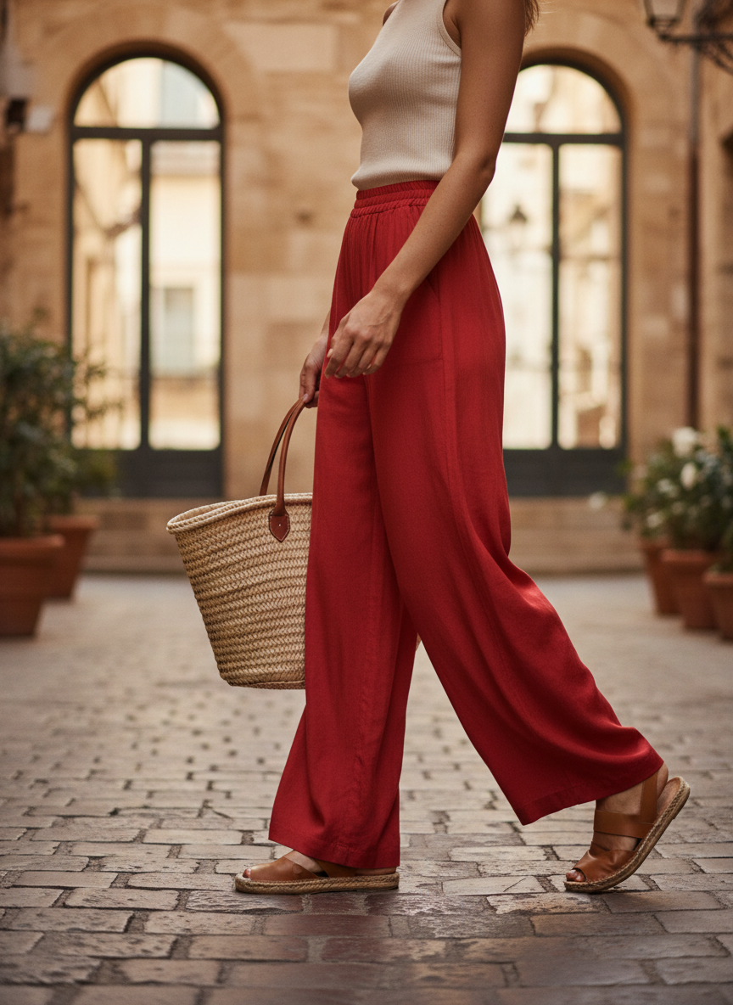

Trousers are a power move for any dinner date. These red wide leg pants look amazing with a fitted black top or a lace corset. This red valentines dinner outfit idea is the definition of classy and elevated. You will feel like a boss walking into the restaurant in these.

# Conclusion

Red is the ultimate choice for a memorable Valentine's Day dinner. These classy and elevated looks will help you feel your absolute best while you celebrate. Pick the style that matches your energy and have the best night ever. Save these ideas to Pinterest now.